**Title: Rafting Site – Planning Document**

**Sections:**

1. **Logo**
   * A logo of Rafting Site

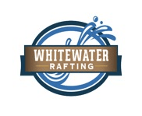

1. **Color Palette**

* primary-color:#C5E8DB
* secondary-color:#C4DACF
* accent1-color:#B9C0DA
* accent2-color:#998DA0
* https://coolors.co/423b0b-b5fed9-98cbb4-7ba098-474935

1. **Fonts**

Heading Font: Oswald

Body Font: Roboto

1. *Site Purpose & Target Audience*:

*The purpose of this site is to promote a fictional whitewater rafting company and attract adventurous individuals and families.*  
*Target audience includes young adults, outdoor enthusiasts, and tourists looking for thrilling water experiences.*